CSC154 Group Project

Sprint 1 Planning Deliverable

Project Name: Online Bakery Ordering System
Team Number: Group 7
Project Manager: Kevin Cunha-Candelaria, Jose Melo
Team Members: Sabine Klabunde, Clarence Bunting, Christian Battle, Yeukai Chingombe
Sprint 1 Dates: September 27th – October 4th

-------------------------------------------------------------------------------------------------------------------

Sprint 1 Goal
The goal of Sprint 1 is to establish the project-management and team collaboration environment, select the project topic, and to submit the Project Overview document.

______________________________________________________________

Product Backlog (Initial Version)
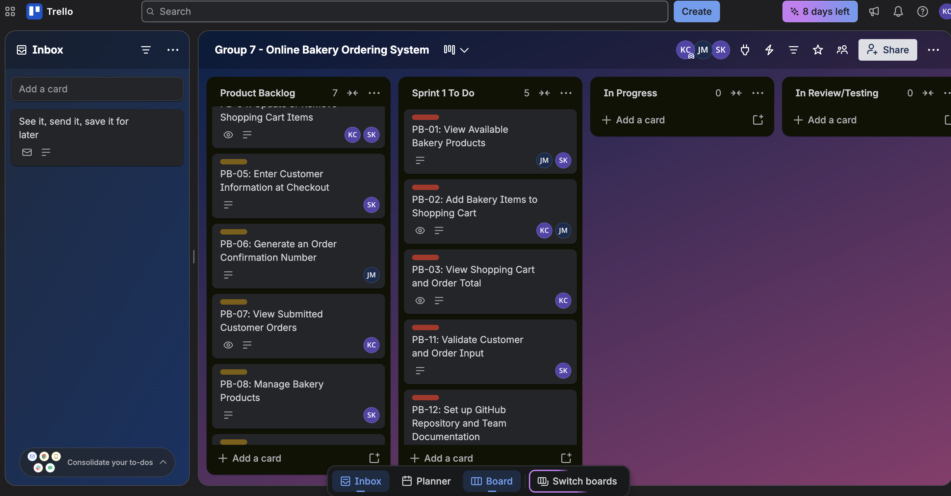

Sprint 1 Backlog
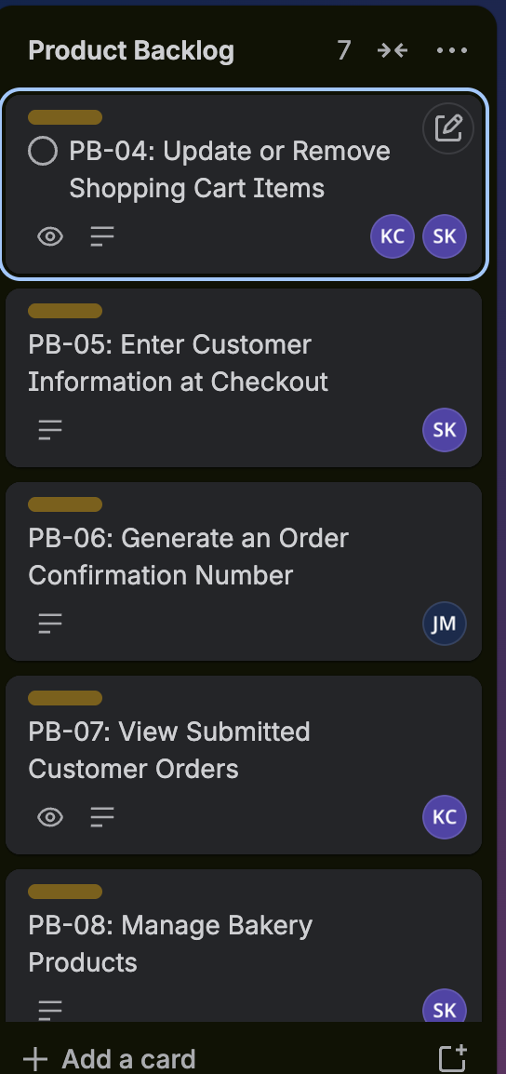

Project Board Setup
